**Topic:** Cavity on Front Tooth in 2022 – Vigoursoul

**Focus keyword:** Cavity on Front Tooth

**Meta Title:** Cavity on Front Tooth in 2022 – Vigoursoul

**Meta Description:** "Cavities in the front teeth are a dental and aesthetic concern. Read on to learn why you get them and what you can do about it."

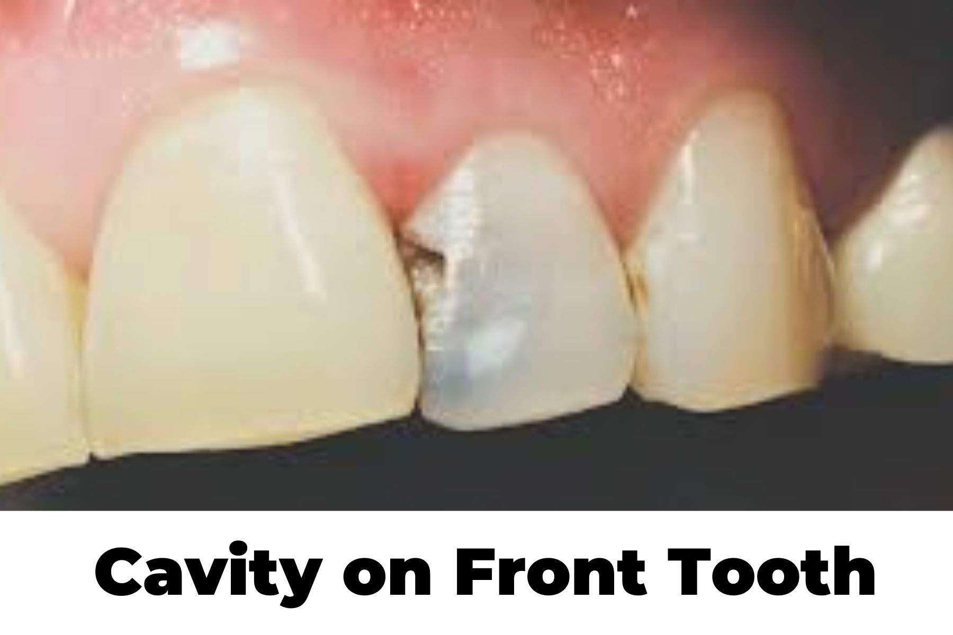

Cavities commonly occur on the rear teeth (molars), however they can also arise on the front teeth (incisors). Cavities on the front teeth are frequently caused by trauma, a lack of proper oral care, or small dental fractures.

**Table of content**

**How to Cover a Cavity on Front Tooth?**

**There are several treatment options, such as:**

* Crowns.
* Dental veneers.
* Composite resin fillings.
* Implants.
* Metal fillings

**Beginning Cavity on Front Tooth:**

**Front tooth cavities typically develop due to several factors, including:**

* Eating sugary foods or drink.
* Failing to brush your teeth.
* Having poor oral health.
* Experiencing acid reflux.
* Limiting fluoride intake.
* Destroying enamel (with coffee, acid, poor oral care, etc.)

**Bad Cavity on Front Tooth:**

Crown - If the enamel has been significantly damaged, a crown may be put on the tooth. Your dentist will first clean out the cavity before crowning the tooth. Filling - A filling is an excellent solution for semi-young cavities. It is simple to use, not as noticeable as a crown, and serves the job well.

**Early Cavity on Front Tooth:**

Cavities on the front of a tooth are less common than ordinary cavities, but they are nonetheless a serious concern. The symptoms of the two forms of cavities are extremely similar, and although rare, front-tooth cavities are not unheard of. It takes a bit more ingenuity to cure them, but it's not impossible.

**How Cavities Form?**

When acids and sugars in the mouth interact with bacteria, a cavity occurs. They accumulate on teeth, forming a sticky material known as plaque. If the plaque remains on the tooth for an extended period of time, it will begin to eat away at the enamel, the hard outer coating of the tooth.

**What does a Cavity look like on a Front Tooth?**

Tooth decay on the front teeth looks the same as decay on the rest of your teeth. The only change is the location of the cavity, which in this situation would be on one of your anterior incisors.

Aside from the cavity's position, everything else about it stays the same. Here are some details on how it appears:

The hue ranges from brown to black.

* A hole can be used to cavitate.
* It may also seem normal and be undetectable without an x-ray.
* Soft texture is an option.
* It can be found in the front, rear, or between the teeth.

**What Causes Cavities in Front Teeth?**

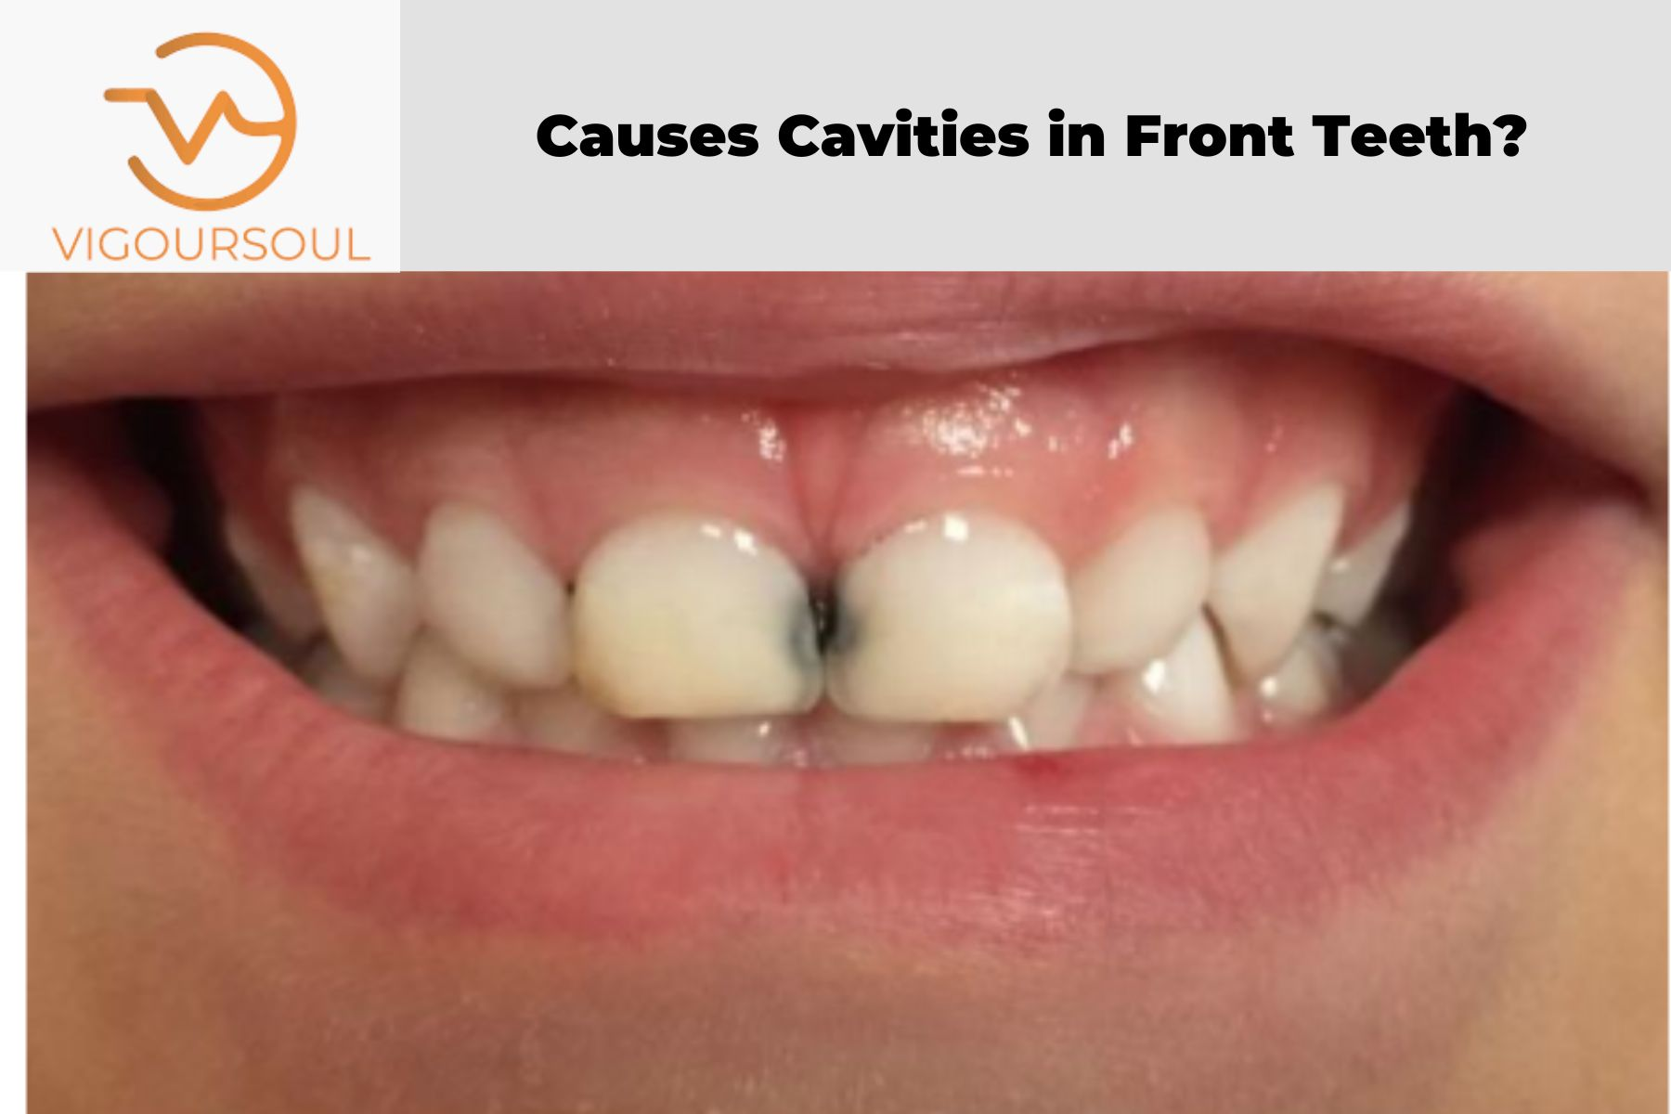

* Cavities in the front teeth occur in adults for the same causes and in the same manner as cavities in any other section of the mouth.
* They are frequently caused by a combination of insufficient brushing and flossing, as well as a diet high in sugary, acidic foods and beverages.
* Certain medical issues and genes can also influence a person's risk of developing cavities.
* When little toddlers develop cavities on their front teeth, it may be due to "baby bottle tooth decay.
* “Most physicians advise parents to avoid giving their newborns and toddlers bottles at night or for extended durations during the day. Natural sugars from milk, formula, or fruit juices may linger in the tongue as a result. Bacteria that might create cavities in infant teeth as a result. Despite the fact that baby teeth eventually fall out, they are critical to a child's oral growth. Cavities at an early age can make chewing and speech difficult.
* Wiping a baby's gums is a good way to start good dental care even before teeth appear. Brushing should become a habit as soon as teeth emerge. The first visit to the dentist should be within six months, or around the baby's first birthday.

**Treating Cavities on Front Teeth:**

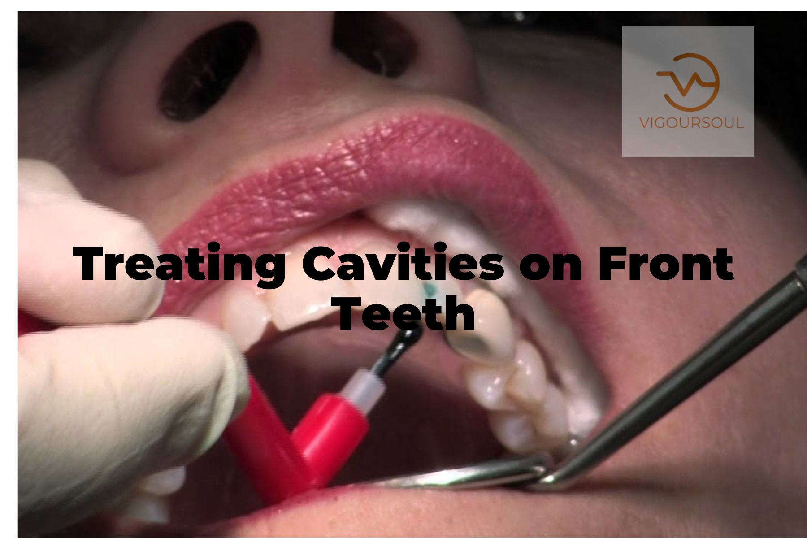

* The therapy for cavities in the front teeth is the same as for any other cavity. Most of the time, this signifies a filling. Because the filling is so visible in the mouth, the dentist will generally prescribe porcelain or composite resin as the material. These materials, unlike gold or silver-colored amalgam fillings, may be manufactured to match the color of the rest of the tooth.
* Veneers are another possibility, especially if the cavity is big and on the front side of the tooth. A veneer completely conceals the front of the tooth. They are less intrusive than fillings. For a filling, the dentist drills a hole directly into the cavity. He or she etches away a considerable piece of the enamel over the whole front surface of the tooth for a veneer, and then cements the veneer on.
* If the decay is extensive, the patient may require a crown to cover the whole tooth. If the cavity is deep enough, they will almost certainly require a root canal operation initially. Crowns, like fillings, are available in materials that can mimic the appearance and feel of genuine teeth.
* Any operation performed to repair a cavity in the front teeth is typically done with beauty in mind. One thing to keep in mind is that dental restorations are not natural tooth enamel. Teeth get discolored or discolored over time. However, fillings, crowns, and veneers will remain the same, making them stand out, especially on front teeth. Similarly, even with expert teeth whitening treatments, they will not alter color. A solid rule of thumb is to consult with your dentist about future teeth whitening plans. They can match the filling or crown to the color of the teeth once they are the desired tint.

## How can you cover a Cavity on Front Tooth?

Here are five methods for removing cavities from your front teeth. Depending on the severity of your cavity, your dentist may use one of the following procedures.

**1. Fluoride Treatment**

If your cavity is still in its early stages, a fluoride treatment may help repair your tooth's enamel and, in rare cases, reverse the cavity.

Fluoride therapy is applied to your teeth by your dentist as a liquid, gel, foam, or varnish or it can be placed in a little tray that fits over your teeth.

**2. Tooth Fillings**

Fillings, also known as restorations, are the primary therapeutic choice when tooth decay has progressed beyond the first stage.

Fillings can be made of a number of materials, including tooth-colored composite resins, porcelain, or dental amalgam, a multi-component composite.

**3. Tooth Crowns**

They are a custom-fitted covering that replaces the whole natural crown of your teeth. If you have significant decay or weaker teeth, you may need a crown.

The dentist removes the entire rotting region as well as enough of the remaining tooth to ensure a suitable fit while installing a dental crown. Crowns can also be made of other materials, such as gold, porcelain, resin, porcelain linked to metal, and so on.

**4. Tooth Extraction**

Some teeth become so severely damaged that they cannot be healed and must be removed. A tooth extraction may leave a space through which your other teeth can migrate.

If at all feasible, you should consider getting a bridge or a dental implant to replace the missing tooth.

**5. Use Fluoride Toothpaste**

Fluoride is required for cavity prevention as well as enamel demineralization. Extensive research has proven that brushing your teeth twice a day with fluoride toothpaste helps to prevent cavities.

Simply get fluoride-based toothpaste and brush your teeth at least twice daily.

**FAQS**

**How do you get rid of a Cavity in your Front Tooth?**

Home therapies such as fluoride toothpaste or mouthwash, as well as oil pulling, can help you get rid of a cavity in your front tooth. If your cavity is more serious, your dentist may advise you to receive a filling or a dental crown.

**What does a Cavity on the Front Teeth look like?**

A cavity on a front tooth may appear as a white spot at first, then turn brown or black until there is a noticeable hole in the tooth. If you have a cavity, you may have increased sensitivity while eating hot or cold foods.

**How long do Flats on Front Teeth?**

A filling can last anywhere from 7 to 20 years, depending on its placement, size, and your oral hygiene. Ask your dentist for a long-lasting filling that won't need to be replaced as frequently.

**Conclusion:**

Maintaining a strict oral hygiene practice is the greatest approach to avoid cavities on your front teeth, even if you've already been treated for one. Brushing for two minutes twice a day, flossing, and using mouthwash on a regular basis are so essential. Furthermore, avoiding sugary, acidic, or spicy meals is essential for avoiding injury. Of course, if you have any further questions or require treatment for your cavity, you should consult a certified dentist right away. Cavities are avoidable and curable, so don't put it off!